**DATABASE MANAGEMENT SYSTEM**

**LAB-10**

**CONNECTING MYSQL TO PYTHON APPLICATION**

**NAME: VISHWAS M**

**SRN : PES2UG20CS390**

**SEC : F**

**DATE : 10/11/2022**

1. Screenshot of database with the table - ‘train’ before populating it.

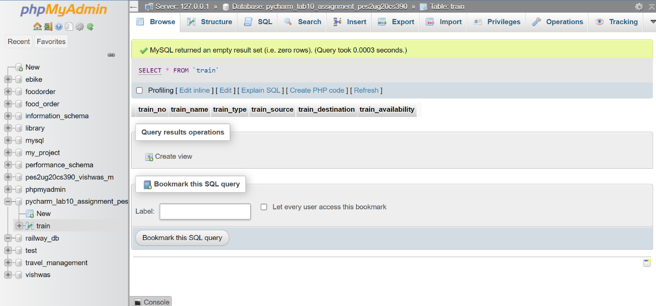

1. Screenshot of the User Interface.

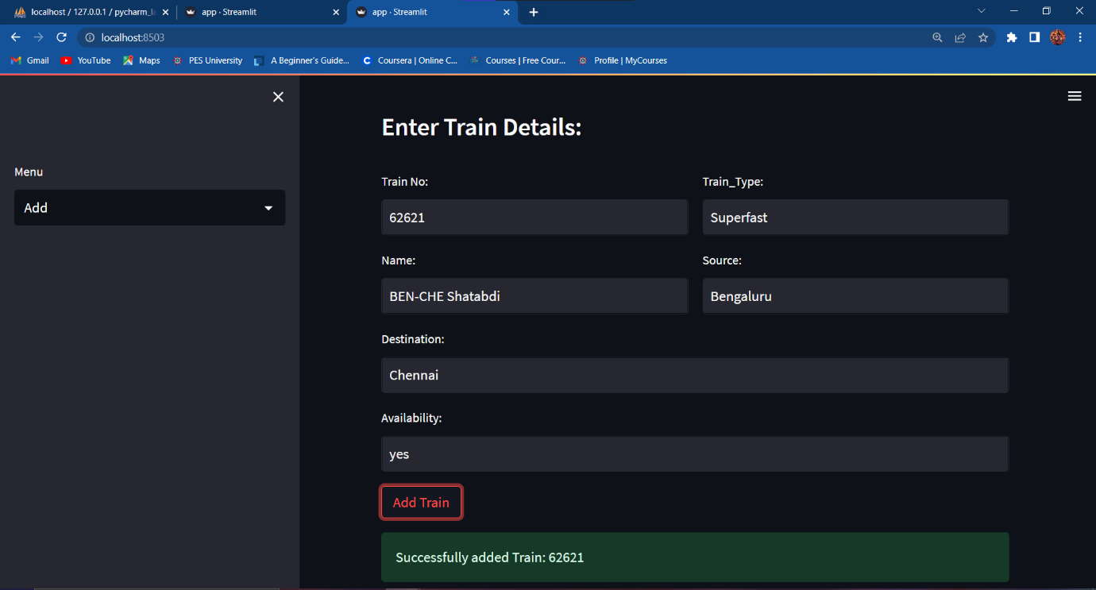

1. Screenshot of the 3 records in the train table from MySQL WorkBench.

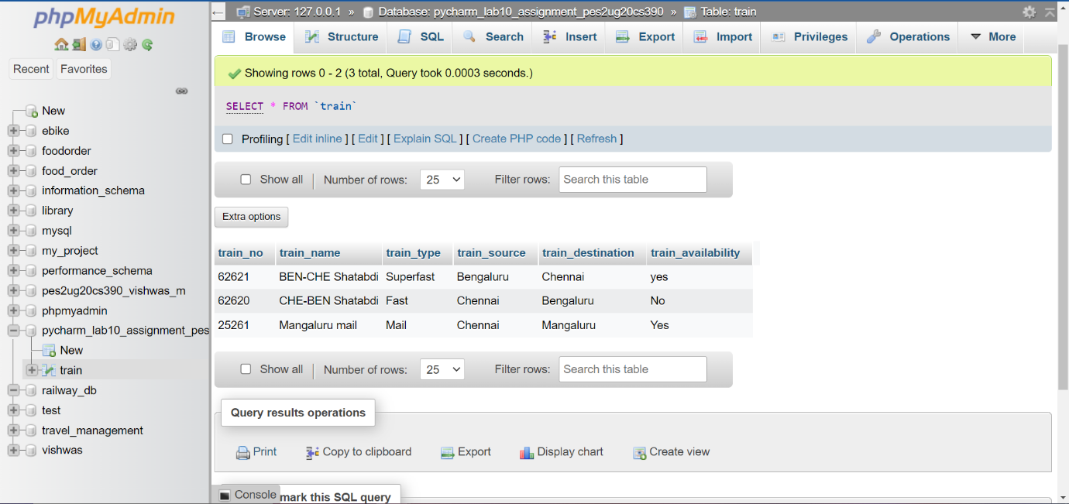

1. Screenshot of the same 3 records visualised in the User Interface.

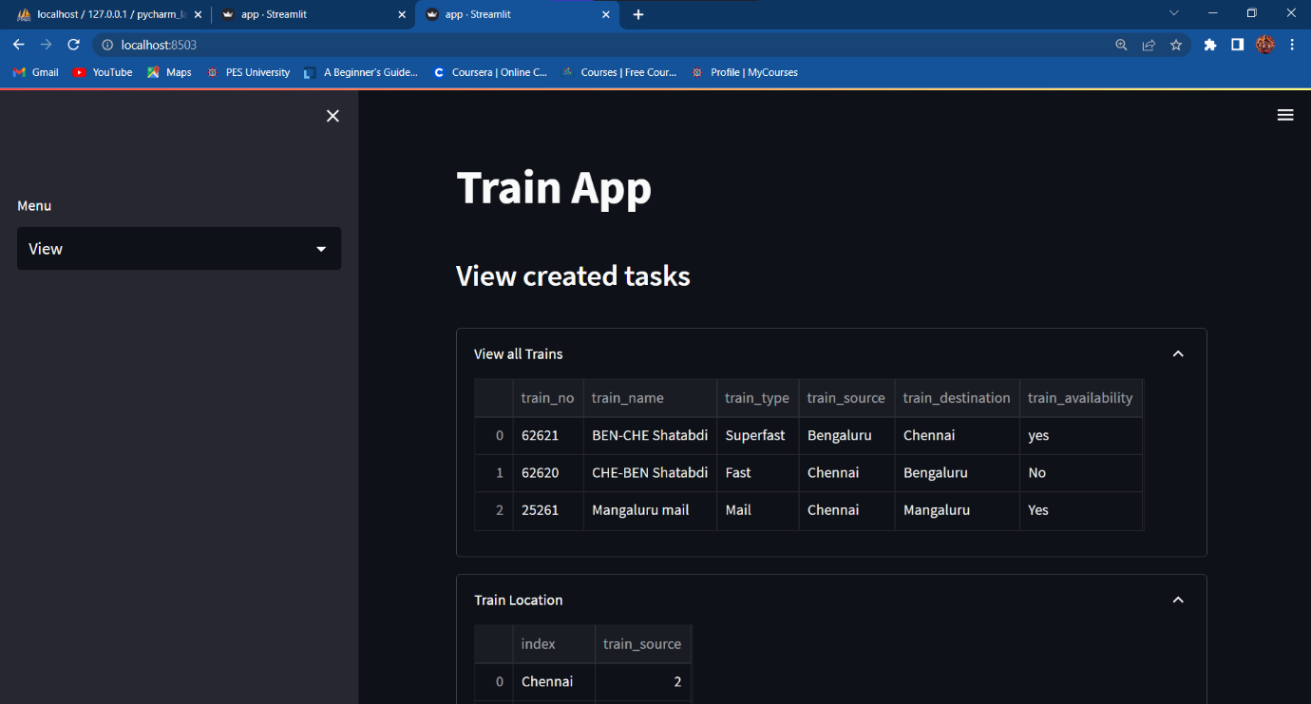

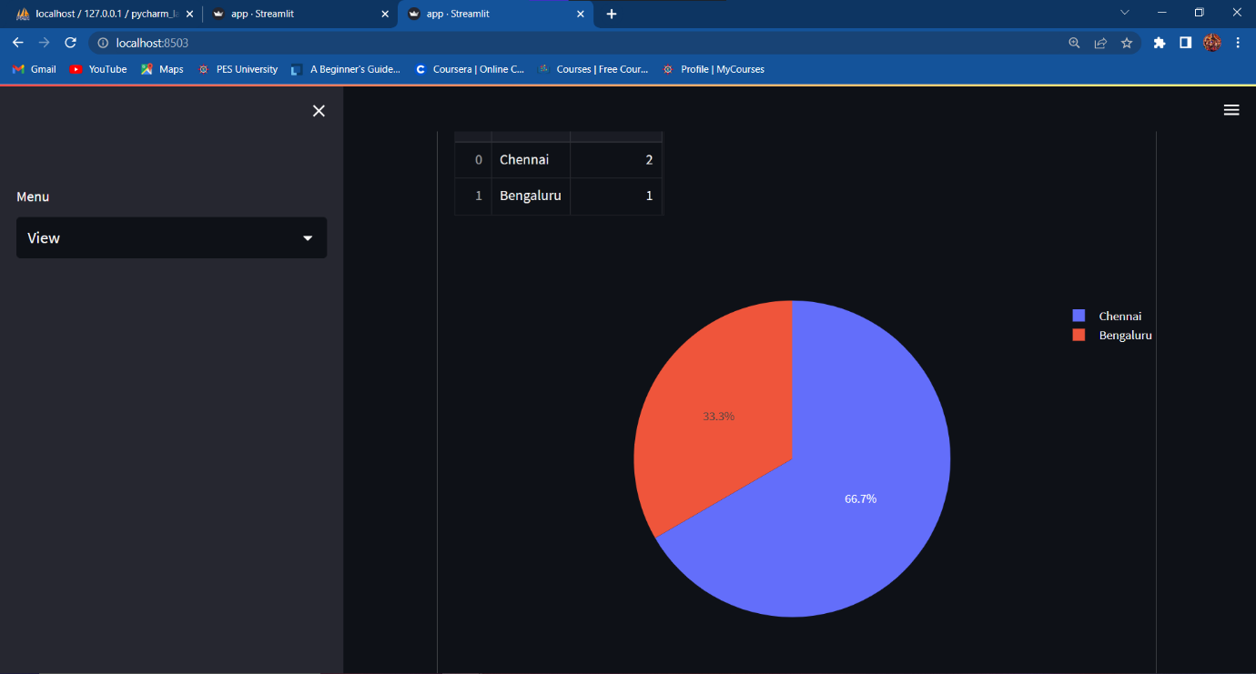

1. Screenshot of Updated Train_No 62620 in the User-Interface.

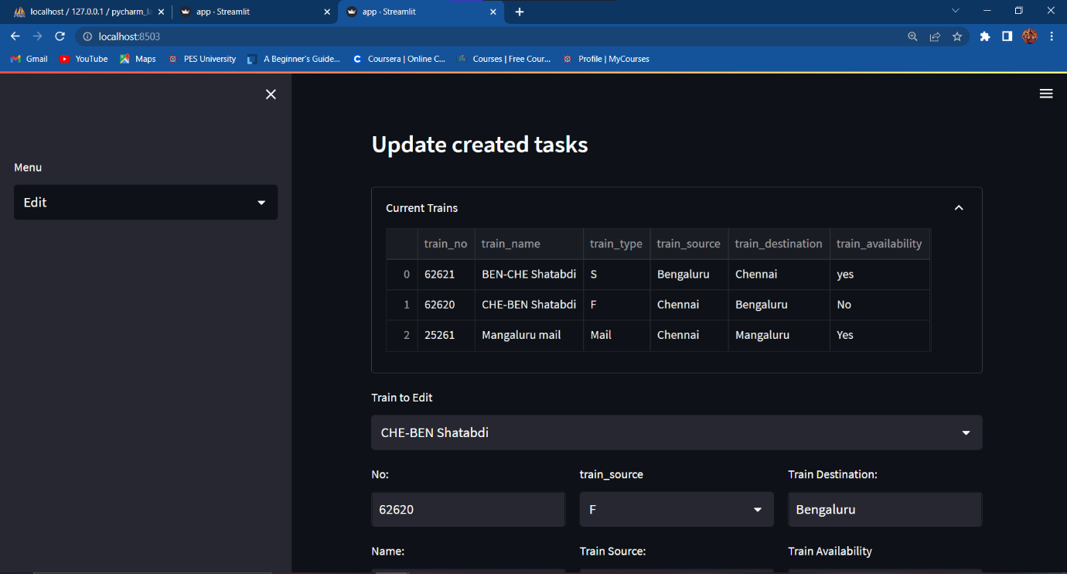

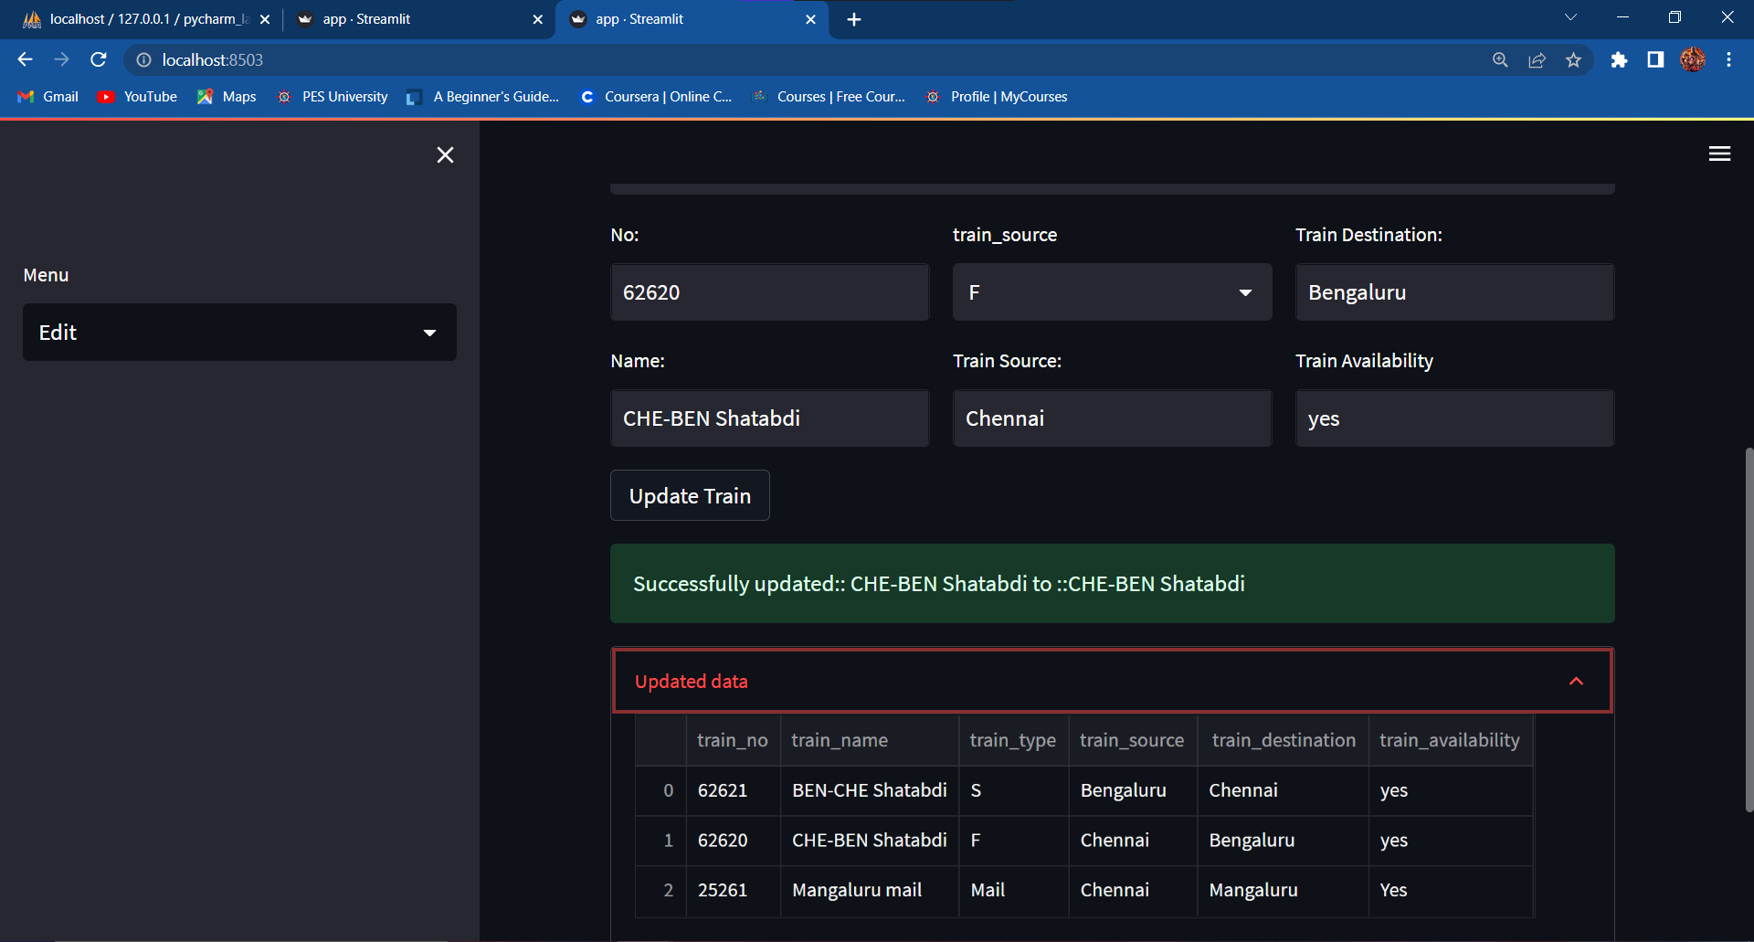

1. Screenshot of User-Interface after the Train_No 25261 has been deleted.

